Calculated Columns:

Create a Calculated Column for 'Category Type': Add a calculated column in the Order Details table that combines the 'Category' and 'Sub-Category' columns into a single 'Category Type' column.
Formula:
Category Type = 'Order Details'[Category] & " - " & 'Order Details'[Sub-Category]

Calculate Revenue per Order in Order Details Table: Create a calculated column in the Order Details table to compute the revenue (Amount * Quantity) per order.
Formula:
Revenue per Order = 'Order Details'[Amount] * 'Order Details'[Quantity]

Create a Calculated Column to Categorize Sales: Add a calculated column named ‘Sales Category’ in the Order Details table that categorizes each order as 'Above Average' or 'Below Average' based on the Amount value.
Formula:
Sales Category = VAR OverallAvg = CALCULATE( AVERAGE( 'Order Details'[Amount] ), ALL( 'Order Details' ) ) RETURN IF( 'Order Details'[Amount] >= OverallAvg, "Above Average", "Below Average" )

Calculated Measures:

Calculate Order Count: Define a measure to count the total number of orders in the Order Details table.
Formula:
Order Count = DISTINCTCOUNT( 'Order Details'[Order ID] )

Calculate Average Profit in Delhi: Create a measure to calculate the average profit for orders placed in Delhi.
Formula:
Average Profit in Delhi = CALCULATE(AVERAGE( 'Order Details'[Profit] ),FILTER('List of Orders', 'List of Orders'[City] = "Delhi"))

Calculate Year-to-Date (YTD) Sales: Define a measure to calculate the total sales amount accumulated from the earliest order date up to each order date.
Formula:
Total Sales = SUM( 'Order Details'[Revenue per Order] )
Year-to-Date Sales = CALCULATE([Total Sales],DATESYTD( 'List of Orders'[Order Date] ))

Data Visualization:
Sales Target Achievement by Category: Compare actual sales with sales targets by category using a clustered column chart.
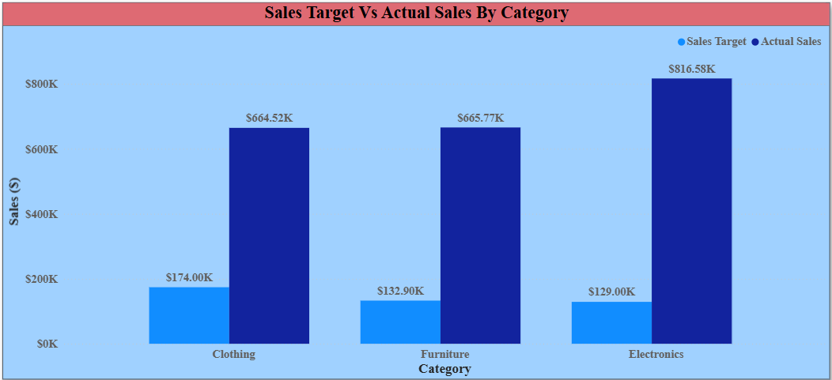

Max Profit Margin by Sub-Category: Analyze the maximum profit margin for each sub-category of products using a donut chart.
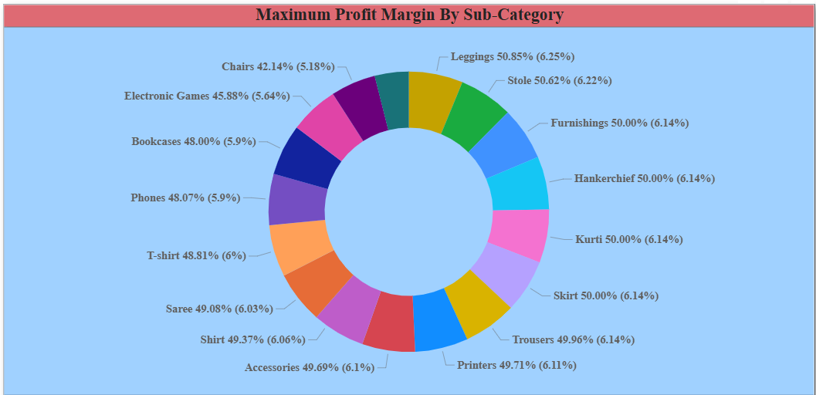

Monthly Sales Trend: Show the trend of monthly sales over time using a line chart.
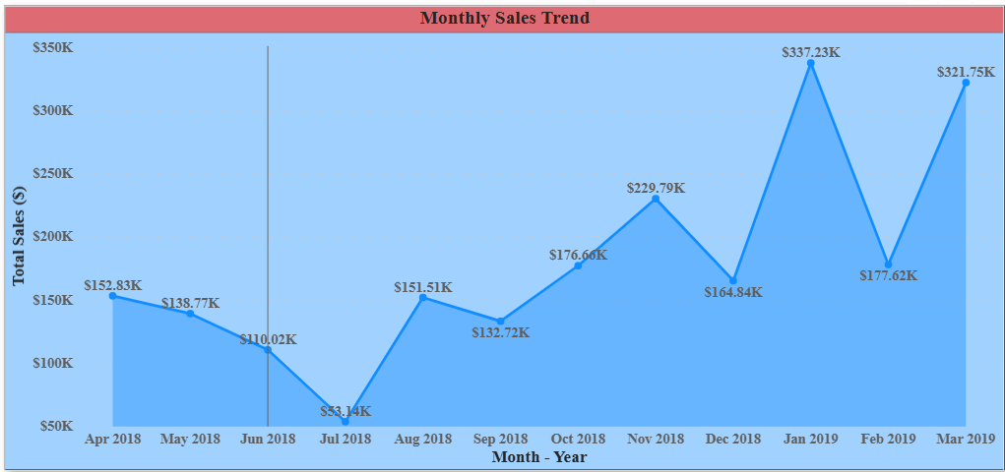

Comparison of Profit and Quantity by Sub-Category: Compare the relationship between profit and quantity sold for different sub-categories using a scatter chart.
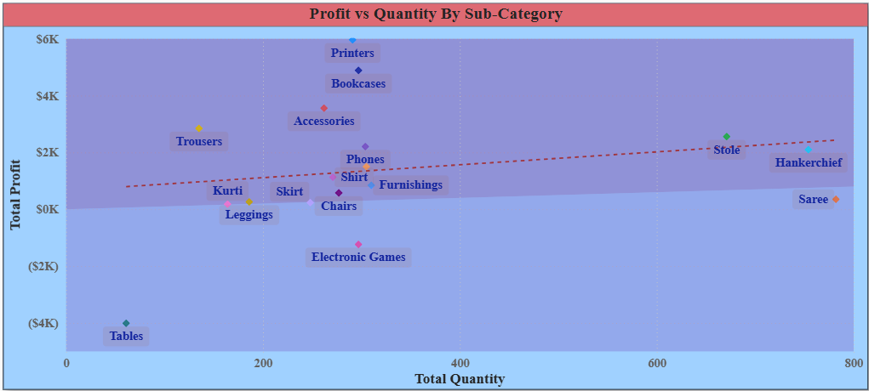

Comparison of Total Sales Amount and Target: Create cards to succinctly display the total sales amount alongside the sales target for quick comparison and analysis. Also, create a multi-row card to display the minimum target for each segment.
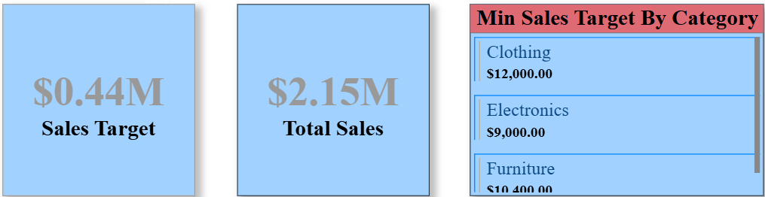

Sales Performance Matrix: Build a matrix view to analyze how actual sales compare to sales targets across different categories and months.
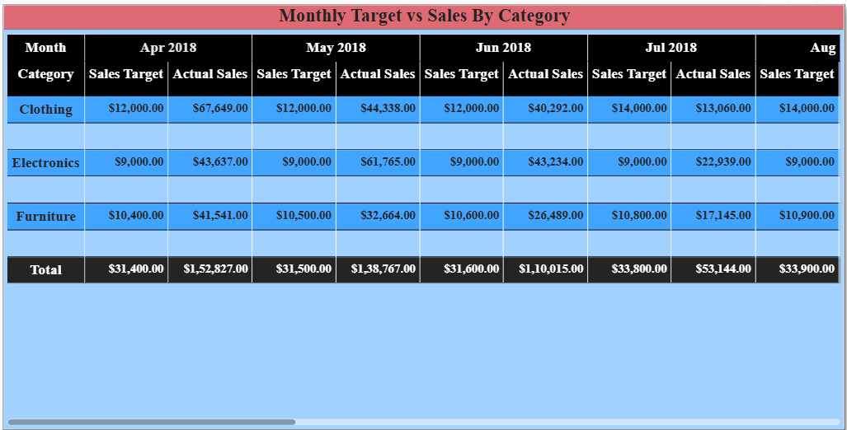

Geographic Sales Analysis: Visualize total sales on a map by city to identify regional sales patterns.
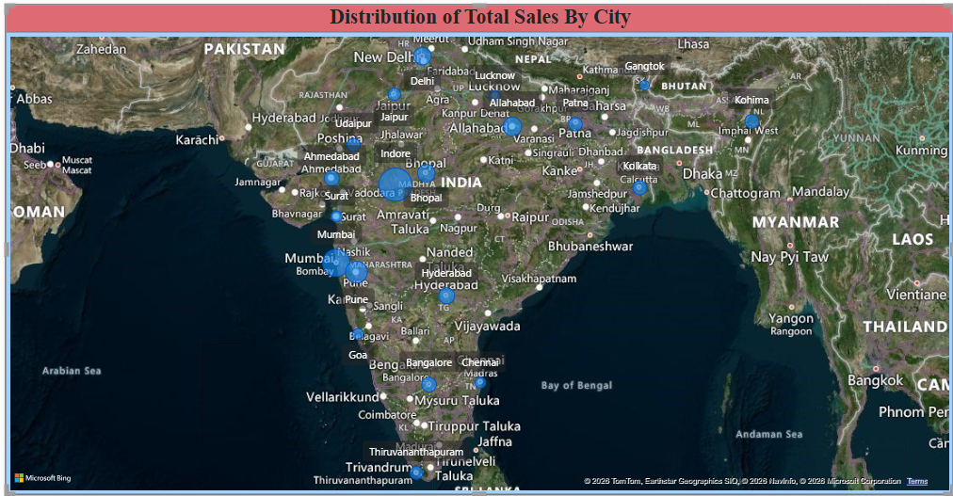

Sales Distribution by Sub-Category: Represent the sales distribution across different sub-categories using a treemap.
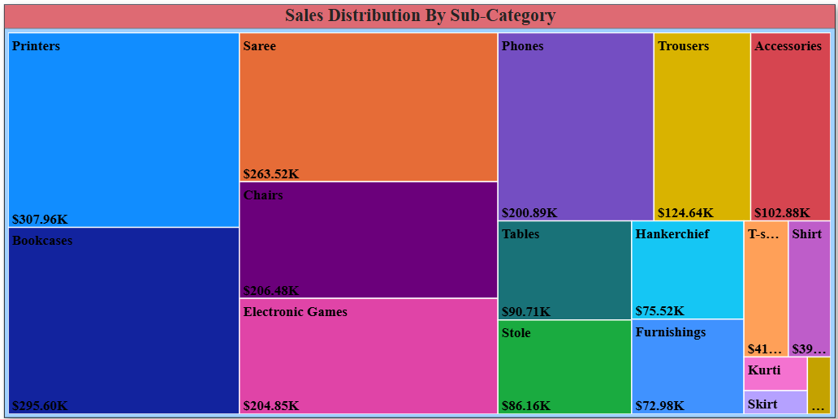

Order Count Analysis by State: Create a funnel chart to visualize the distribution of order counts across different states.
